MEDIA RELEASE – for immediate release

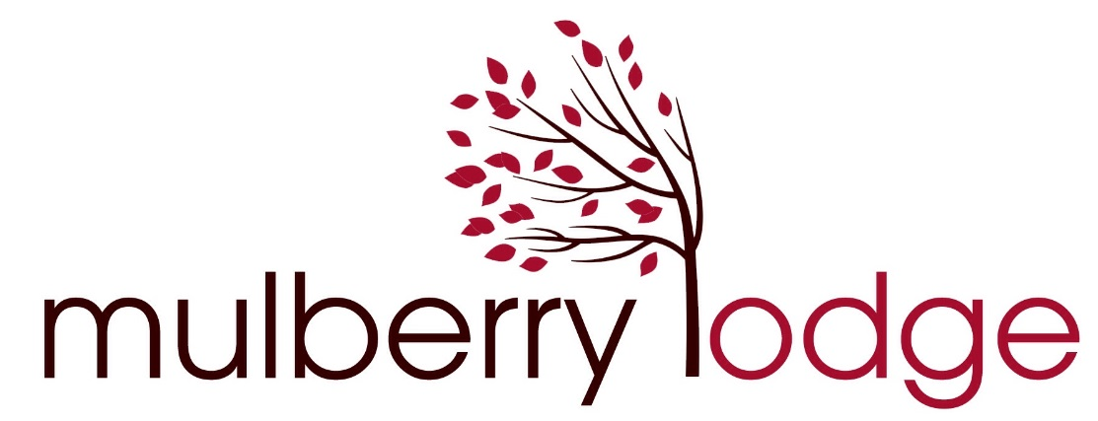

MCLAREN VALE: HOME OF SOUTH AUSTRALIA’S BEST HOSTED ACCOMMODATION

The South Australia Tourism Awards night on Friday 4 November saw Mulberry Lodge Country Retreat named as Winner of SA Tourism Awards Hosted Accommodation for 2016. Owners and hosts Hazel and Nik Parker were at the gala dinner to receive the award from SA Tourism Commission Chairman Sean Keenihan.
Hazel Parker said “winning this award is great news for Mulberry Lodge and is the culmination of three years developing the business to be one of SA’s best boutique country retreats. Nik and I are delighted to receive this award and we take great pride in being recognised among our peers as the winner of SA hosted accommodation for 2016.”
Mulberry Lodge Country Retreat in Willunga is a boutique escape from the busyness of everyday life, offering a tranquil garden setting among the beautiful vineyards of the McLaren Vale. Renowned for their outstanding hospitality, Hazel and Nik welcome every guest as if to their own home and ensure they leave as friends. A beautiful private suite is within easy reach of Hazel’s famous breakfasts and enthusiastic recommendations of the very best places to wine, dine and experience in the stunning Fleurieu Peninsula, just 45 minutes from Adelaide CBD and international airport.
“Thank you to the team at SATIC for their fantastic support and encouragement, and to SATC as award sponsors. We’d also love to thank all our guests over the last year for their wonderful comments which have undoubtedly been a very important part of Mulberry Lodge being named best SA Hosted Accommodation for 2016”.

Ends

Contact: Hazel Parker 0424 825 965
hazel@mulberrylodgewillunga.com
www.mulberrylodgewillunga.com

